**Title: Digital Forensics**

**Name: Muhammad Hamad**

**Assignment # 1**

1. **HASHES**
   1. **USB**

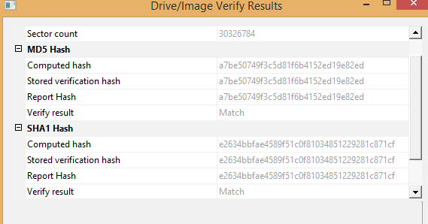

* 1. **DFR-01**

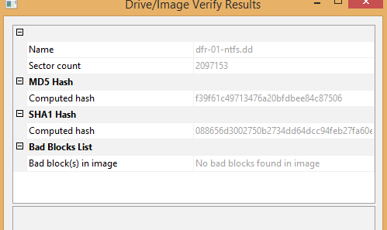

1. **PARTITION DETAILS:**
   1. **USB**

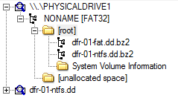

* 1. **DFR-01**

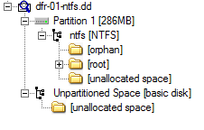

1. **No of Files and Deleted Files**
   1. **USB**
      1. 10 files, 0 deleted files
   2. **DFR-01**
      1. 15 files, 3 deleted files.